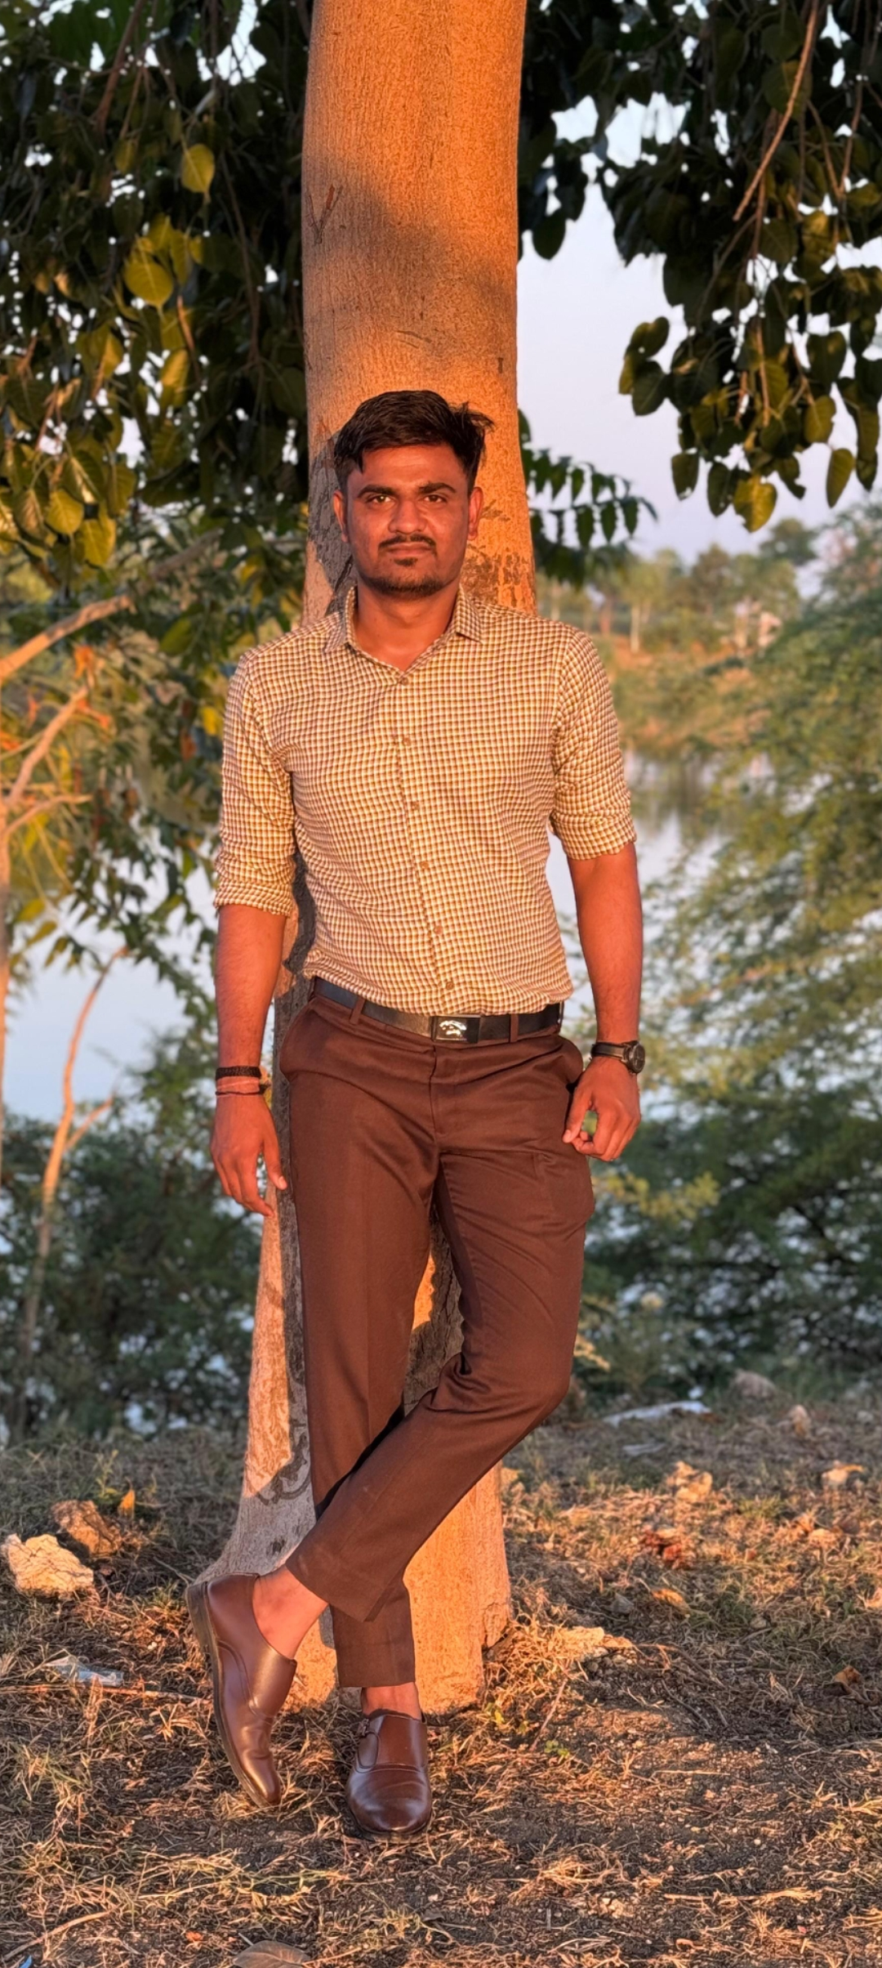
`

PERSONAL DETAILS

Name:
Address:
Cast:
Education:
Hobby:
Occupation:
MY STATISTICS
Utsav Jagdishbhai Ghori
C-1502, Blossom homes,

Nr. ABC circle, Mota Varachha,
Surat
Hindu Leuva Patel
BCA (2 Year Completed)
Travelling, Music
Textile
Date of Birth:
Height:
Weight:

30
2002
th August,
feet 9 inches
5
66
Kg
FAMILY DETAILS
Father's Name:
Mother's Name:
Brother:
Sister in-law:
Native Place:
Jagdishbhai Punabhai Ghori
Late. Shilpaben Jagdishbhai Ghori
Satish Jagdishbhai Ghori (Married)
Nimishaben Satishbhai Ghori
Village: Ranparda (Khara),
Taluka: Palitana,
District: Bhavnagar

MATERNAL DETAILS
Name:
Native Place:
Sureshbhai Balabhai Munjapara
Arvindbhai Balabhai Munjapara
Village: Budhana,
Taluka: Shihor,
District: Bhavnagar
